2016 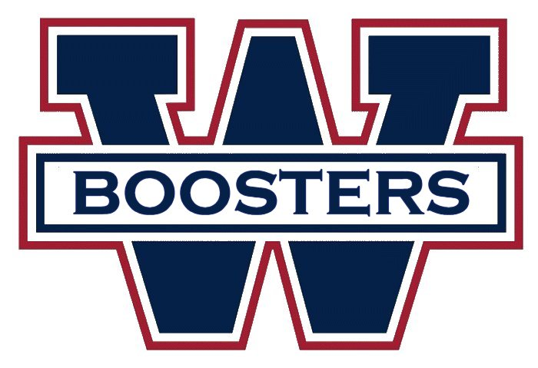 2018

Membership Application (Good for the 2017-2018 season!)

Dues: _____ Individual ($10) _____ Teen (13-17) ($5) _____ Senior (65+) ($5) _____ Kids (12+ under) (Free)

_____ Max Family (All in same household) ($25)

Name: Date of Birth: / / .

Address: Date of Anniv: / / .

City: State/Prov: Zip: .

Home Phone: ( ) Work Phone: ( ) . Cell: ( ) .

E-mail Address 1: . E-mail Address 2: .

If applying for a Family Membership, please list names & birthdates of all other family members. All must live at the address listed above to qualify for a Family Membership.

Name: Birthdate: / / .

Name: Birthdate: / / .

Name: Birthdate: / / .

Name: Birthdate: / / .

Name: Birthdate: / / .

Are you a season ticket holder? No Full Half 12-Game

Would you like more information about joining the Board of Directors, or a committee (Membership, Trips, Fundraising, Awards & Events, Youth, Newsletter)? YES!

Would you like more information about involvement in club activities (Away game trips, broomball, charity (50-50), concessions, game nights, festivals/parades, player meet and greet, pool, bowling, skating, DEK hockey, etc)? YES!

Cash is accepted at the booster club table for payment, but please don't send it through the mail - use a check or money order for mail applications. To start your membership, return this completed form with the appropriate fees via mail or at the booster club table at any home game. Please make check(s) payable to:
Worcester Hockey Booster Club
Attn: Membership
PO Box 210
Grafton, MA 01519-0210

As a member of the Worcester Hockey Booster Club, I/We agree to abide by the Constitution and Bylaws set forth by the WHBC.

Signature: Date: / / .

Booster Club Use Only Date Paid: / / . Amount $ _________ Check/Cash _______ Collected by: _________________________.

BECOME MORE THAN A FAN……..

JOIN THE WORCESTER HOCKEY BOOSTER CLUB!

The Worcester Hockey Booster Club is a non-profit, independent, volunteer organization that is dedicated to the promotion of Worcester’s professional hockey club, to promote hockey in central Massachusetts, to contribute charitably to the Worcester County community, to provide enhanced and expanded opportunities for hockey fans and boosters at both home and away games, and to foster camaraderie and social/recreational activities for Booster Club members.

ANNUAL MEMBERSHIP DUES

$10 Individual
$5 Teen (13-17) and Seniors (65+)
$25 Max price for Families (in same household)
Free for Children 12 & under

MEETINGS

General Membership Monthly Meetings (meet players! get your hockey club info directly from the club!)

BOOSTER CLUB BENEFITS

Discounted Tickets & Bus Trips for Away Games
Annual ECHL Booster Club Convention (Jamboree)
Annual Holiday Party
Annual Players Awards Banquet
Vote for Player of the Month / Year Award
Various Community Events - Toy, School Supplies, Clothing, Canned food drives. Participate in parades and festivals!
Discounts on merchandise, services, food - via Corporate Perks and Mass Buying Power programs

BOOSTER CLUB CHARITABLE ACTIVITIES

50/50 Raffle - We have raised over $70,000 for local charities such as Friendly House, Relay for Life, Local Red Cross Disaster relief, Mass Veterans Shelter, Pernet Family Health Services, Autism Speaks, Andrew's Helpful hands, WTAG Christmas for Children's Fund, and many, many more!
Booster Seats Program - donate your unused game tickets to local charitable groups - to families and kids who may not have the financial means to attend a game, but could use a night out.
Annual Toy Drive
Youth Hockey Scholarships

The success of the Worcester Hockey Booster Club has been accomplished by the participation of the members in the many committees and Board or Directors. Your commitment can be small or large. We welcome participation at any level. Join a great group of people who share a common interest & have fun at the same time!
Join the Worcester Hockey Booster Club today!

